Textual analysis - The eternal sunshine of the spotless mind - Isaiah Mogado

The film I am analysing is the Eternal Sunshine of the Spotless Mind, a comedy/drama based on a couple who’ve forgotten each other. It was released on March 19, 2004 and was directed by Michel Gondry. The film covers a plethora of different topics and genres as it also represents the genres of psychological thriller, science fiction and romance in order to explore the themes of love versus the concept of the ill mind.

The film's story is about two characters that fall in love but then remember that they have fallen in love before, Clementine undergoes a process to forget about the last relationship and so does Joel. The film although non-linear still keeps in line with Todorov's theory of Narrative. The equilibrium is where both characters first meet and everything is calm, the disruption comes along where they discover they were previously lovers and then try to erase that from their minds and it reaches a new equilibrium when they later meet in a similar spot to the beginning where Joel asks if they can start anew.The non-linear ordering of the film also adds a lot to the film since we're skipping through the character's mind and further exploring the key theme of romance mixed with fading memories.

The story of the film isn't very similar to the two genres it is meant to portray within Comedy and Drama because both of them are so different. The plot is incredibly thick and well thought out. It links the two genres through heartbreak and romance which is a general theme of many comedic/drama mixes. The film also links to another poem by Alexander Pope, Eloisa to Abelard which shares the theme of romance and memory where the heroine’s only comforting factor in life is her forgetfulness.

The film is set in the city it is set in, New York. A place incredibly famous for film and TV and has a certain glamour to it in the sense that it is so well known. The characters however aren't as atypical as the actors as in my opinion Jim Carrey goes a bit more than just the generic jester of the film and provides a lot more of his character. The film has more intertextual references other than the name as the name of the company which aids in erasing Clementine’s memory is called Lacuna inc, meaning a gap or that something is missing. This goes back to the condition lacunar amnesia which is the same as the latin word Lacuna but focuses mainly on one singular event in the life of the person.

The boy (Joel) is represented as a very serious looking adult who seems to be incredibly awkward around the girl (Clementine) and she is portrayed as the opposite to him, very outgoing and unafraid to start a conversation with him as Joel is shown to mainly be

The extract I am describing starts at around 8 minutes in where Joel meets Clementine and we see this “love at first sight” thing happen between both characters with a lot of focus from Clementine’s perspective and Joel plays a more reactive character. We see back and forth a lot of references to the idea of skinny love where it seems that two people like each other but not really wanting to say anything about it to each other. The shot reverse shots used between dialogue mainly are controlled by Clementine because she is primarily driving the conversation. This is one of the stranger parts regarding to genre, as in most romances it still remains patriarchal. The male figure is meant to approach the female and they seem to have gone into a swap of gender.

The editing for this scene tries to show a very fast paced love as it breaks the conventions of typical slow paced romance stories as it’s a foreshadowing of the future. They’ve been here before. The bus scene in terms of editing actually goes a lot slower than the scene where the two of them are drinking, possibly suggesting that the bus scene was more important in suggesting the love between the characters. The way the film is edited is very intimate, constantly switching between Joel and Clementine during their conversation sequences. Perhaps trying to suggest again the love between the characters.

There is also a huge genre convention where Joel drives Clementine home and then she awkwardly invites him in for a drink, they go in and this scene in other romantic films usually involves a hot drink, but not alcohol since you see Joel drive there. They go in for a drink and the alcohol could potentially be another foreshadowing of the film, to forget when the relationship turns sour. This could be a metaphor for alcohol which in a lot of cases is used to forget and usually has a very sour feeling that comes along with it. Perhaps a reference to Clementine, alcohol is meant to soothe you, make you feel better and judging from Joel’s very closed demeanour Clementine is meant to open him up as a character.

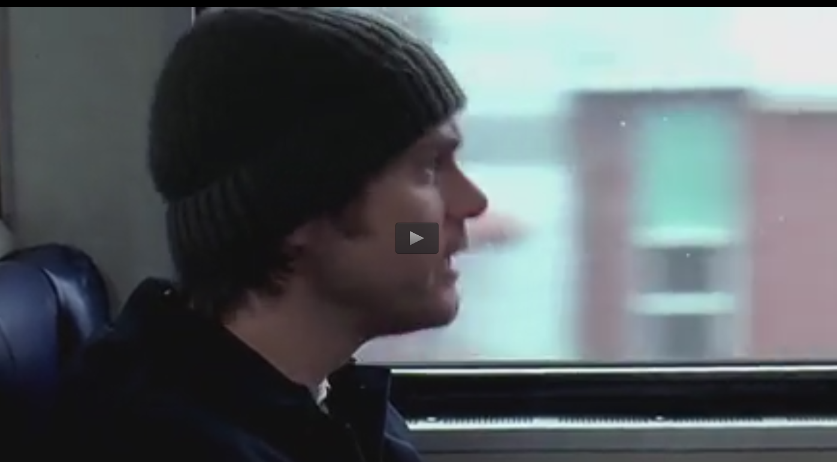
This shot is part of the conversation between Joel and Clementine, meant to highlight the semi awkwardness of Joel’s character and juxtaposes with Clementine’s outgoing nature. I chose this still because Joel’s facial expressions and body language are slightly weak. His back is slightly hunched over since he’s briefly looking up from his work and he has a concerned yet agitated look upon his face.
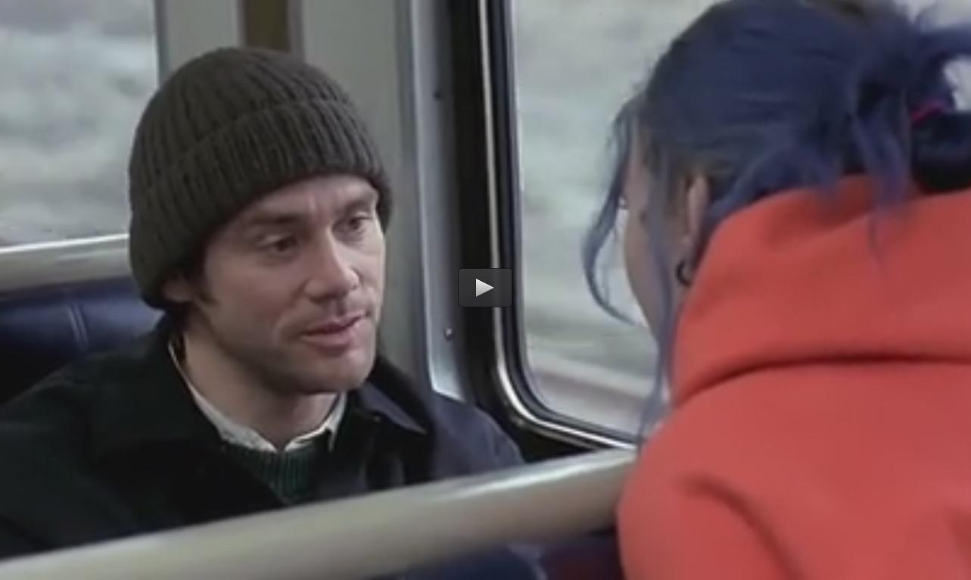
This shot highlights a more intimate conversation between the two, again you see the awkwardness upon Joel’s face now that Clementine is more “up close and personal” to Joel, his body language remains the same from the first screenshot and his facial expression is more awkward than anything. Showing the fact that Joel isn’t accustomed to people like Clementine and how to deal with them during conversation. Or mainly showing a figure of shyness due to the budding romance and the fact that Clementine is a very dominant figure in the relationship as she carries the conversation along.

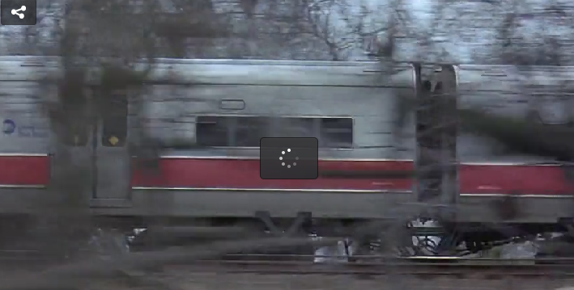
This is a shot of the train highlighting a lapse in time, the importance of this is the concept of time and how the film is basically two lovers lost in an everlasting love because they can’t remember anything beforehand and fall back in love throughout the film. The fact that in the next shot the day looks incredibly similar albeit there is a shot meant to highlight a gap in time represents that more so. The setting involves a train travelling through the country during the winter as shown by the dead trees and the clothing the characters wear in the shots before this. The winter is often shown as a season of death, the trees are leafless and typically crops and plants don’t grow during the winter very easily. This again suggests a dying relationship between the two characters as shown by the outside surroundings. 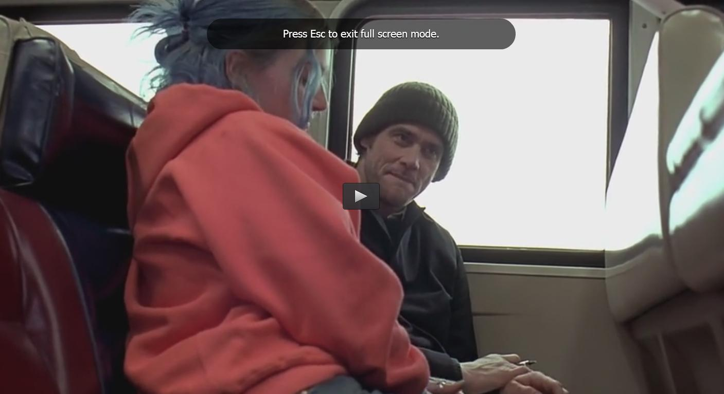
Again, another shot trying to highlight the relationship between the two characters. Albeit this is a swap of the confidence of the characters. In this we see Joel take charge of the conversation by his more open body language versus Clementine’s new closed demeanour. Trying to suggest that they are “made for eachother”, that they can solve each other’s problems and when one person is in a rut the other can make up for it.
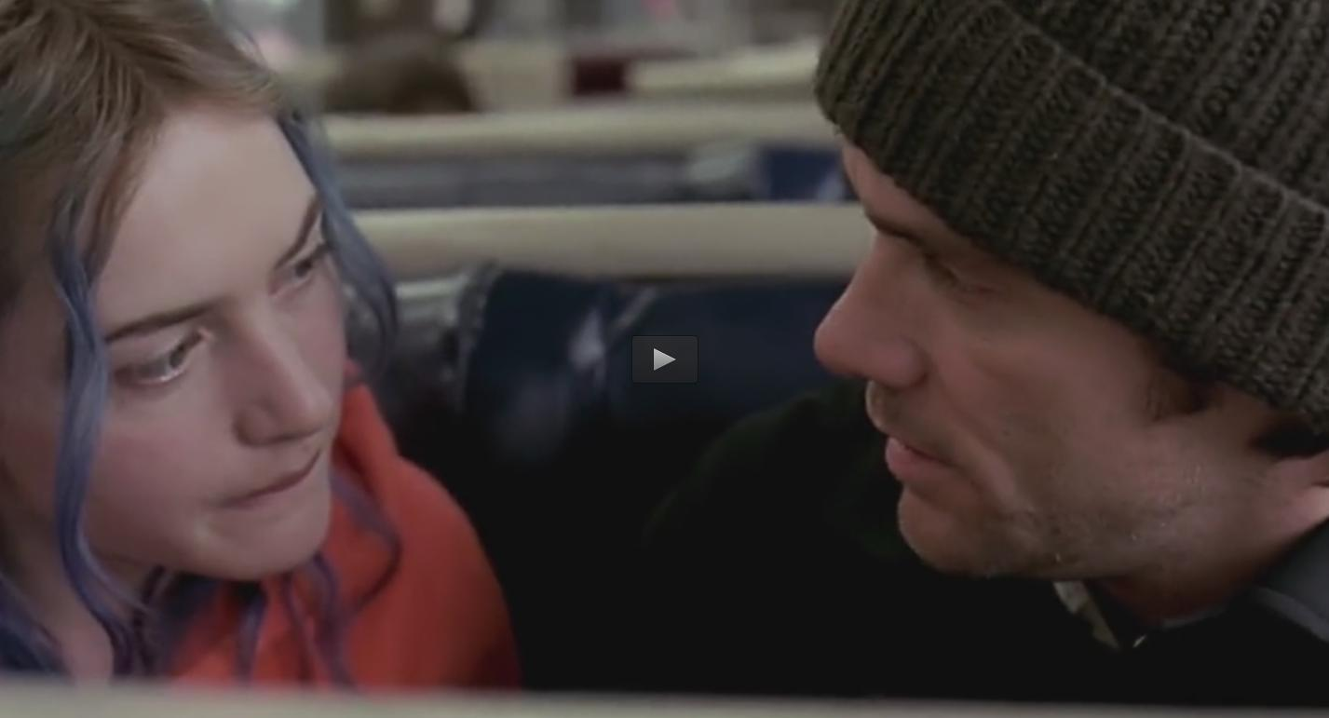
awkward break in conversation
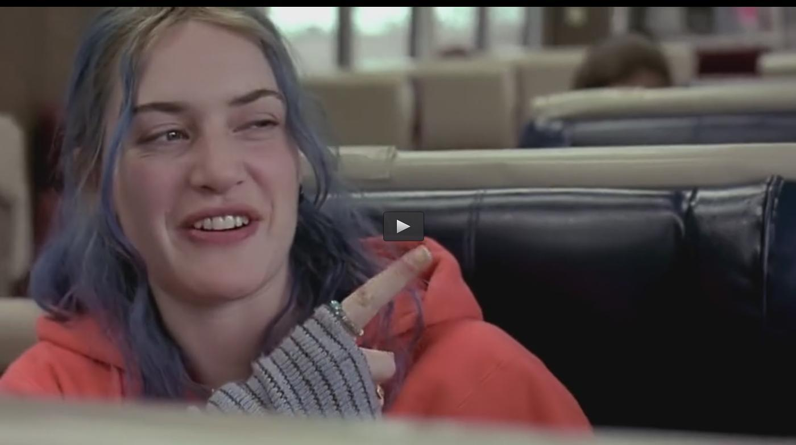
joking punch
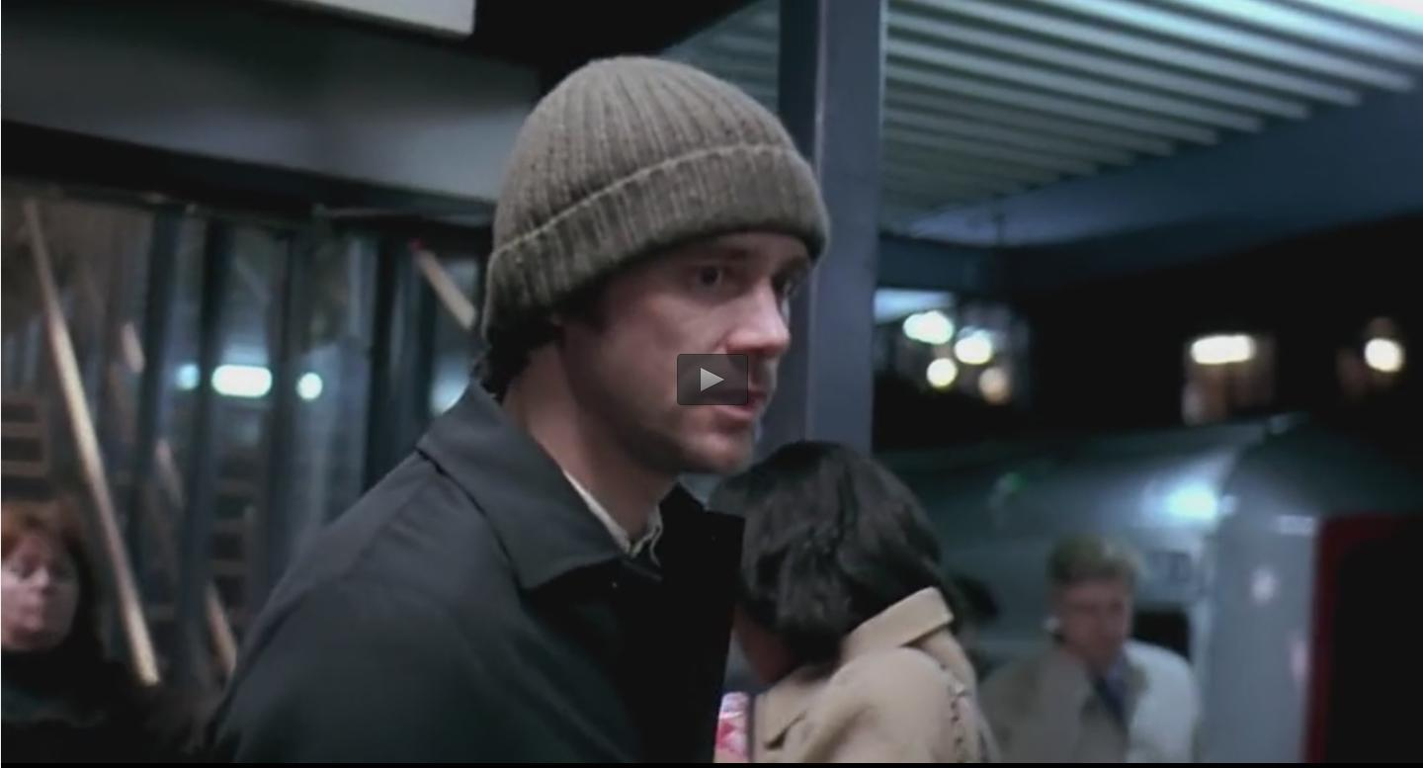
Joel without Clementine, very silent etc…
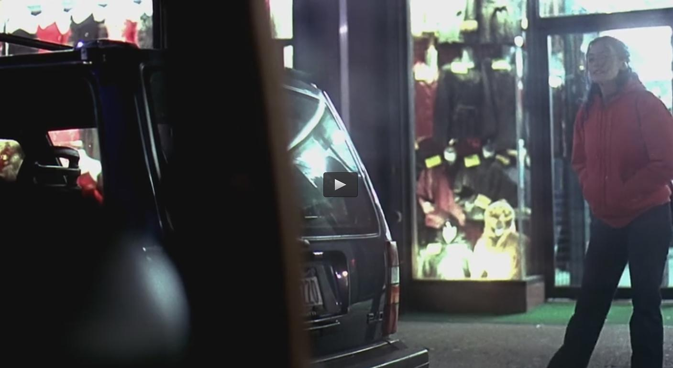
Joel pulling up to Clementine, asking if she wants a lift.
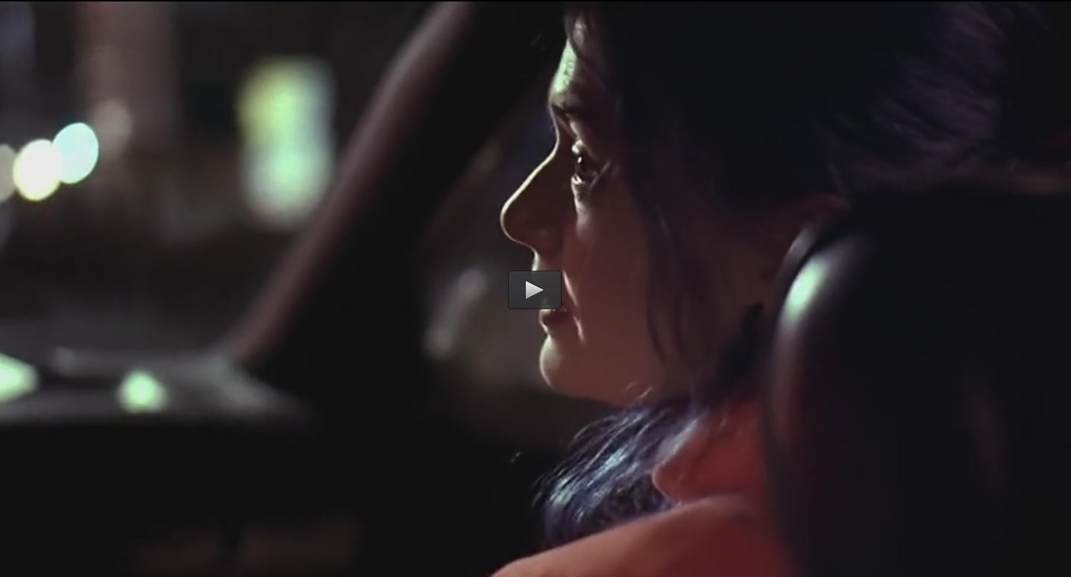
In car conversation, shot reverse shot, apologetic conversation
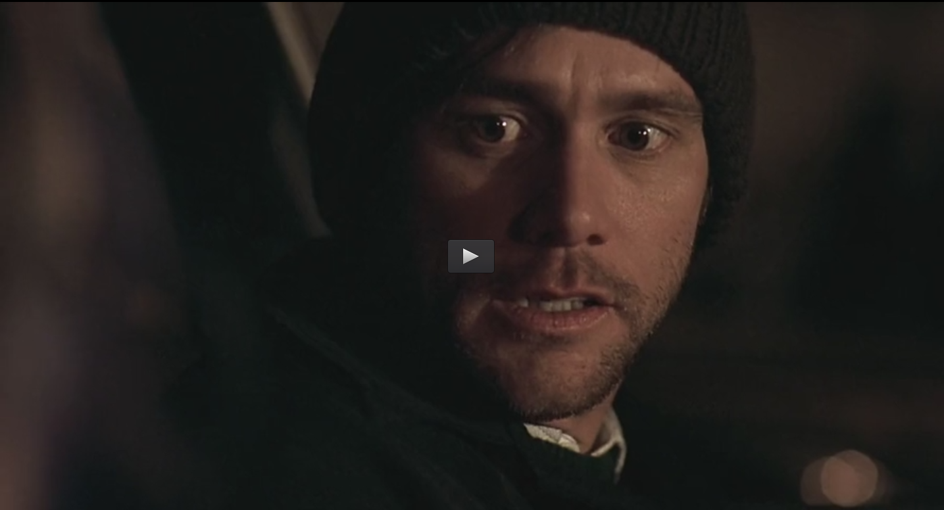
Clementine offers Joel a drink

