the slogan at the top ‘get the hot girl, defeat her evil exe, hit love where it hurts. This indicates both Rom-com and action for the genre.
All the characters are young people so suggests it’s a film aimed at teenagers.

The characters on the poster do resemble video characters from the bold make-up of the blonde haired girl, the lighting up of the guys eyes and the stern facial expressions as though they are ready for a fight.
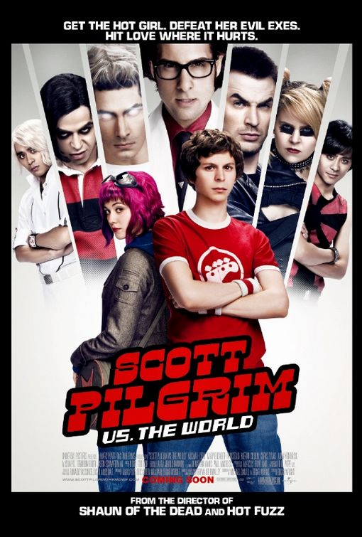
With the layout of the characters and the splits between them suggests an action film as it resembles the start of a fight level in a video game. Which could also be hinting at a key element of the film which would be a unique selling point.

The fact that the female with the pink hair and male in the red stand in the centre of the poster suggests that they are in the middle of the fight and the crucial characters in the film. Her bright pink hair, red lipstick, sunglasses and cool facial expression and pose suggests she is the hot girl in the slogan

the fact that ‘scott pilgrim’ is in red and is written in a bigger font than ‘vs the world’ hints of his importance. The font is bold also indication action.

They also include the fact that the director is the same director to Shaun of the dead and hot fuzz which are two very well-known British comedies so we also know that it will be a comedy. This instantly draws in the audiences of those films and anyone who enjoys comedy

