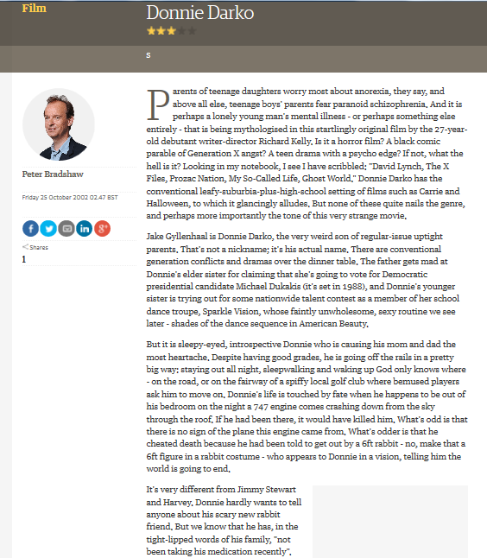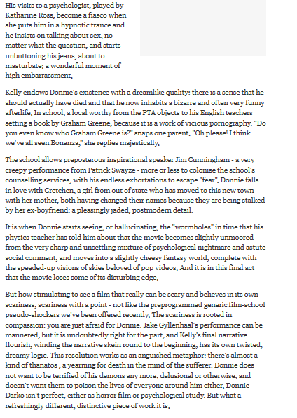
At the start of the review he focuses on 27 year old debut writer director Richard Kelly
Confusion about the genre “is it a horror film?” “What the hell is it”
In the middle part of the review he focuses on the characters and the narrative
Use of informal language for general reader
Talks about genre conventions
“leafy-suburbia-plus-high-school setting” comparisons to other movies with similar but not the same feel
“This very strange movie” first impressions
“Jake Gyllenhaal is Donnie Darko” mentions the main actor because he is known
“Conventional generation conflicts” comments on narrative
“A psychologist, played by Katharine Ross” mentions this actor but does not mention the real names of the father of mother probably because of the popularity of the actress
Not much on use of camera or special effects up to this point
“A very creepy performance from Patrick Swayze” again mentions well known actor
Comments on the special effects towards the end of the review “the "wormholes" in time” describing it effect on the movie as “slightly unmoored” “slightly cheesy fantasy world”
He calls the movie “stimulating” because of its uniqueness, the appropriate performance from the actor and the narrative by the director
Does not comment of the flaws of the movie, just hints towards how it is different and does not belong to a specific genre but by the way he says this makes it a good thing.

