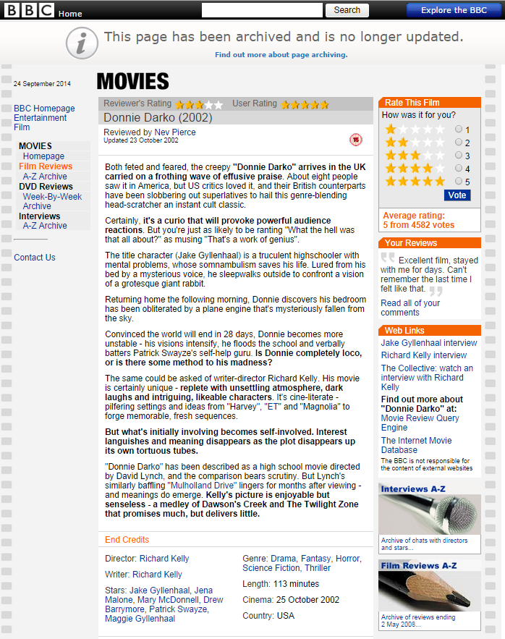
This movie review of donnie darko is mostly informally written making it relatable to the general reader, the context of the review is to make the reader more interested about the movie and in general increase the general knowledge of the reader about the movie, it does this through focusing on different things such as the narrative. the director and the main protagonist are also mentioned, the review also tells the reader a bit about the setting while not mentioning the use of camera and the special effects used because its not exactly an analytical review but rather an informative one, this is also shown through the use of references to other movie; the writer does this to make the reader relate to the movie. the writer also gives personal views and other peoples views on the narrative and the movie in general.
The review discusses how the movie is simply mind blowing but still confusing to the viewer while still being a master piece he does this through critiquing the director; his use of mise-en-scene and references, at the end of the review he describes the movie as enjoyable but senseless

