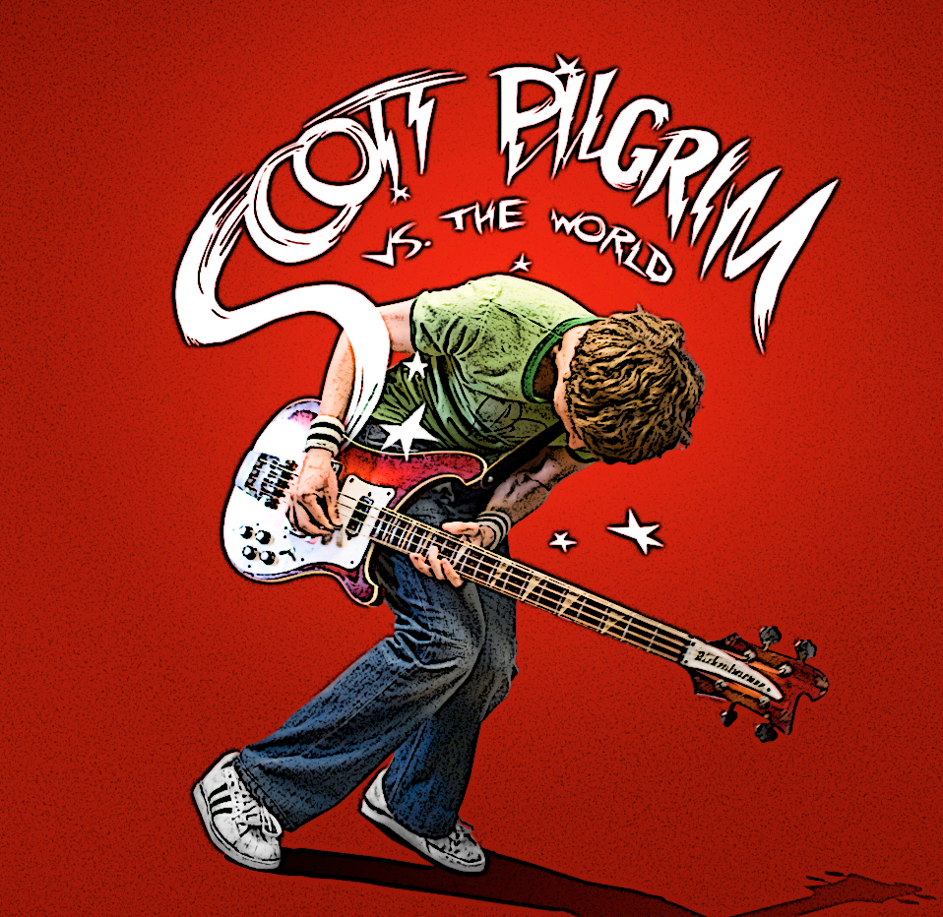

The Rolling stones review on Scott Pilgrim vs The World is written in an informal manner and he even goes as far as describing one character as a ‘the ultimate rat bastard’. There is large focus on the actors in the film and Peter Trevers even goes as far as mentioning each character and the actor that plays them. ‘Knives Chau’ (the wonderful Ellen Wong)’, ‘Stacey (sassy Anna)’, ‘Wallace Wells (a sensational, Scene-stealing Kieran Culkin). Such descriptions give an idea that the review is written for a teenage audience who would be attracted to the film by the main actors involved. Other than the actors the narrative of the film is a key element of this review. The narrative is described through the entire review helping the description of each character flow. There is also focus on the director Edgar Wright. His previous films ‘Shaun Of The Dead’ and ‘Hot Fuzz’. His work is described to have ‘the power of Wright’ who’s previous work ‘exploded every cop cliché’ this helps to excite the audience and make them want to watch the film since the director has clearly had big successes in the past that have been very different to any other movie of that genre. Special effects aren’t mentioned in the review however it is brought to the reader’s attention the fusion of media involved with a ‘blends of music, comics, manga, anime and video games’ which instantly draws in a wide audience of many interests. He also praises the ‘visual wonderland’ that is the cinematographer Bill Pope who helped wright to create it.
The New York Times review is clearly for a slightly older target audience bearing in mind the paper in which it has been written and the first line of the review ‘There are some movies about youth that just make you feel old, even if you aren’t’. The use of description in this review is a more formal manner ‘speedy, funny, happy-sad spirit’ and the film is said to be ‘infectious’. There is a focus on location and the fact that it is filmed in Toronto as is many others. The different character types are all depicted in the review and although the actors are mentioned there is very little said about them. The main focus in the review is the narrative however which focuses the fact of it’s originality as many of the different media aspects are mentions such as gaming with ‘Pac-Man’, ‘Dance Dance Revolution’ which gives older readers a chance to reminisce of their own teenage years and find relation with the characters and therefore stopping the film from feeling restrictive. Overall the description of the film is of wider vocabulary and is more in-depth which signals an older audience in comparison to the shorter more informal style of the first review signalling a younger audience.

